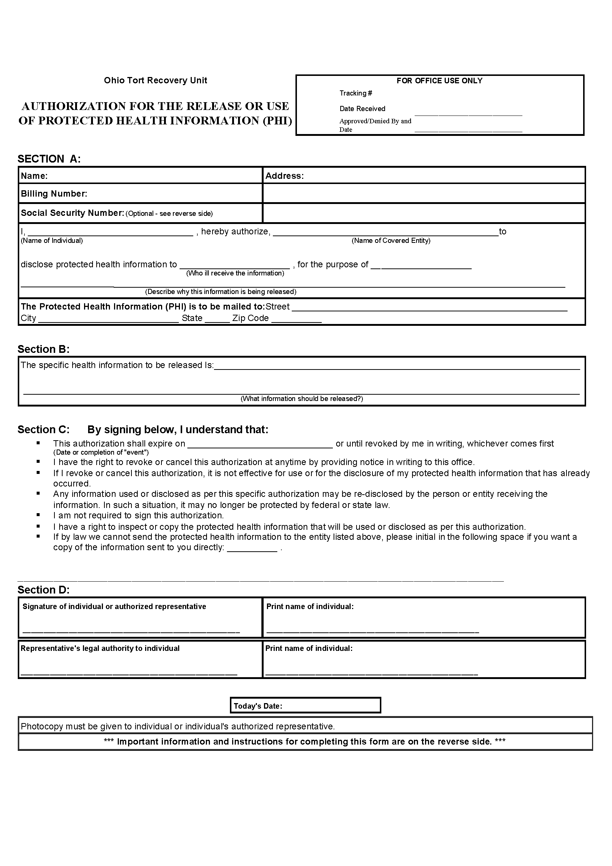
Batman
xxx-xx-5555
Batman
Axiom Requisition
Litigation
2869 Jolly Road
Okemos
MI
48864
FROM 01/01/1979 TO PRESENT: Any and all MEDICAL RECORDS, including but not limited to patient history form(s), reports, etc. pertaining to Batman SSN: xxx-xx-5555, DOB: 01/01/1979.
End of Litigation
University of Michigan Hospital and Health Center
